d dAfric aAI: R unbook - SSGADD – SSGA
Summary | We are looking specifically for duration data from State street global advisors.
Source name | State street global advisors - SSGA
Link to the source | SPDR BBG Barclays High Yield Bond ETF - JNK: SPDR® Bloomberg High Yield Bond ETF  SPDR Portfolio Intermediate Term Corporate Bond ETF - https://www.ssga.com/us/en/intermediary/etfs/spdr-portfolio-intermediate-term-corporate-bond-etf-spib
Dataset name | SSGA Duration Data - SSGADD
Frequency | Daily
SLA | Each measure need to be updated once daily during the week before 10am EST.
Expected Time | NA
1.1. Navigate to the first source URL:
https://us.spdrs.com/en/etf/spdr-bloomberg-barclays-high-yield-bond-etf-JNK?fundSeoName=spdr-bloomberg-barclays-high-yield-bond-etf-JNK
https://www.ssga.com/us/en/intermediary/etfs/spdr-bloomberg-high-yield-bond-etf-jnk

1.2. Scroll to the Option Adjusted Duration from the Fund Characteristics section:

2.1. Navigate to the second source URL:
https://us.spdrs.com/en/etf/spdr-portfolio-intermediate-term-corporate-bond-etf-SPIB
https://www.ssga.com/us/en/intermediary/etfs/spdr-portfolio-intermediate-term-corporate-bond-etf-spib

2.2. Scroll to the Option Adjusted Duration from the Fund Characteristics section:
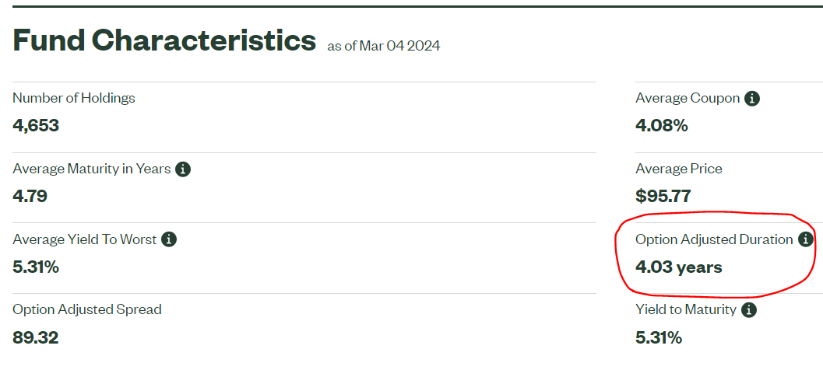
A data point must be completed for each business day.
For cases where the new point did not come out, fill in the point for the previous day.
For example, you fill out the release on the morning of March 6 for March 5 and see only the point for March 4. Enter the March 4 value into the March 5 data point.

Please monitor the data in the set for the last few days. If you see a point as of the date that was already filled in earlier, but is different from the current one, you should fill in, in addition to the release for today, an additional revision for the previous day.
For example, on March 6, we fill in the period for March 5, there was no update source on the website, and we put an end to it as of March 4.
When we fill in the data on March 7, we noticed that there is an update available on the site as of March 5. We need to complete the March 5 revision in this case.
Save data in SSGADD_DATA_YYYYMMDD file.

Requirements to the data provided by AfricaAI
Data files format
For on-boarding new datasets and processing new releases the following requirements are applied:
- there should be one archive in .ZIP format that contains 2 files provided in .XLS format per one release - one file with DATA and one file with METADATA (both files are mandatory). Archive name should be as "DATASET_YYYYMMDD.ZIP"", where "DATASET" - specified abbreviation for a dataset, "YYYYMMDD" - timestamp when the file was created, where YYYY - year, MM - month number, DD – day;
- the files format is strictly defined and cannot be changed by AfricaAI team.

File with DATA
Template for file name: “DATASET_DATA_YYYYMMDD.xls”, i.e.” MEXPENFND_DATA_20220601.xls”
Requirements to the file with DATA:
- format - XLS, encoding - Unicode (UTF-8);
- file name: should follow pattern "DATASET_DATA_YYYYMMDD.xls", where "DATASET" - specified abbreviation for a dataset, "YYYYMMDD" - timestamp when the file was created, where YYYY - year, MM - month number, DD - day;
- file content:
  - data is provided on one sheet only (multiple sheets are forbidden);
  - two-dimensional format where rows represent reported periods and columns contain timeseries values;
  - reported period(s) should be provided in the following format:
    - for data with daily/ weekdaily frequency: YYYY-MM-DD, where YYYY - year, MM - month, DD – day;
    - for data with weekly frequency: YYYY-WW, where YYYY - year, WW - week number (should be two-digits, i.e. 2022-01, 2022-02, etc.). Week number is defined based on the reporting date: reporting date is considered the end of the week, i.e. if reporting date is Wednesday the week is calculated from Thursday till Wednesday – based on that rule the number of the week is defined;
    - for data with monthly frequency: YYYY-MM, MM - month number (should be two-digits, i.e. 2022-01, 2022-02, etc.);
    - for data with quarterly frequency: YYYY-QX, where YYYY - year, X - quarter number;
    - for data with annual frequency: YYYY, where YYYY – year;
- values to be provided in decimal format with "." as delimiter (number of digits after "." is limited only by provided value by the source). In order to interpret data correctly the following requirements are applied:
  - if provider specifies for reported period that data is Not Available (that could provided in corresponding notes or other way) - fill in that data point with "NA" value;
  - if provider does not specify that data is Not Available and report Empty value for reported period - leave Empty cell;
  - if provider skips some of reporting period - skip it also in the file with data as well;
- column names to be provided in two first rows: in the first row - timeseries ID (CODE), in the second row – timeseries description (description in DATA file is identical to description in file with METADATA).
NB! Timeseries with different frequencies could be provided within the same file as there are different patterns for providing reported periods

File with METADATA
Template for file name: “DATASET_META_YYYYMMDD.xls”, i.e.” MEXPENFND_META_20220601.xls”
Requirements to the file with METADATA:
- format - XLS, encoding - Unicode (UTF-8);
- file name: should follow pattern "DATASET_META_YYYYMMDD.xls", where "DATASET" - specified abbreviation for a dataset, "YYYYMMDD" - timestamp when the file was created, where YYYY - year, MM - month number, DD - day;
- file content: specified metadata attributes that are static unless provider changes something or new timeseries should be added. In case of new timeseries should be added/ updated/ changed - escalate that to Data Engineering team Special BWAT-DFAC Data Engineering <SpecialBWAT-DFACDataEngineering@epam.com> at and Cc: Data Operations team at Special BWAT-DFAC DataOps <SpecialBWAT-DFACDataOps@epam.com>
Notes on METADATA fields from file “DATASET_META_YYYYMMDD.xls”
- With every data release attach file with METADATA
- With every release change only on attribute in the file with METADATA in column “NEXT_RELEASE_DATE” – set “YYYY-MM_DDThh:mm:ss” (YYYY – year, MM – month, DD – day, hh – hour, mm – minutes, ss – seconds. Time should be provide in UTC time) to the time when the next release is going to be processed.

Saving ZIP archive on SFTP
Save the releases in specified per “DATASET” folder (you may create new folder for new DATASET in case of absence of such folder).
Details on SFTP are the following:
- Dev env
Host: africaai.datadev.dfac.io
- PRODVAL env
Host: africaai.prodval.data-factory.io
- PRODHA env
Host: africaai.prodha.data-factory.io
Port: 22

